DAT 554 Final Project:

Anxiety Attacks and Their Severity: A Data-Driven Analysis of Lifestyle and Physiological Factors

Charushree Anil
Abstract—The effects of anxiety attacks on mental health are considerable and the severity can be influenced by lifestyle, physiology and psychological status. Here we investigate a set of over 12,000 data points across demographics and lifestyle, including sleep, exercise, caffeine, and alcohol consumption, along with health metrics including heart rate, respiration rate, and body temperature. High level data pre-processing and feature engineering as well as application of machine learning models such as Random Forests and XGBoost for pattern detections and correlations. Findings indicate main influencing factors such as stress vulnerability and lifestyle scores, with high predictive performance (R² = 0.985 for XGBoost regression, classification accuracy = 100%). These results could contribute to the identification and prevention of risk, as they are easily deployed, particularly when combined with wearable sensors.

INTRODUCTION
Anxiety disorders are the most frequent mental disorders worldwide. More than 280 people worldwide are estimated to have an anxiety disorder, reports the World Health Organization (WHO). The severity and frequency of such attacks differs, and they are generally elicited by a combination of behavioural routines, physiological stressors, and psychological sensitivities. Accurate prediction of anxiety episodes may facilitate early intervention and symptom severity reduction and enhance quality of life. This research explores the following question : (1) Are there behavioural and physiological characteristics that can predict the occurrence as well as the severity of panic attacks? (2) What are the most important panicscorrelating features? (3) Is it possible to divide the population into risk groups for targeted mental health strategies? Leveraging statistical and clustering methodologies, and machine learning approaches, this study offers data-driven insights into behavioral and physiological dimensions of anxiety attacks.

Related Work
The relationship between anxiety disorders and lifestyle-related diseases such as cardiovascular disease, diabetes and obesity, and the physiological mechanisms of these interactions has been widely investigated, while the application of machine learning (ML) and statistical techniques has opened new possibilities in mental health research. Heart rate variability (HRV) and respiration rate, for example, are effective indicators of anxiety attacks. For example, Al-Khalidi et al. [1] show that variations in heart rate variability (HRV) are strongly correlated to the event of anxiety episodes, providing a promising use case as a predictive feature. Likewise, lifestyle factors, such as sleep deprivation, caffeine intake and alcohol consumption, have been shown to aggravate anxiety severity. A study by Zhang et al. [2] show that chronic disruption of sleep causes a 30% increase in anxiety symptoms, suggesting the need to include such variables into analytical models.
There has also been much focus on treatment methods. Various treatment strategies including Cognitive Behavioral Therapy (CBT), pharmacotherapy, and mindfulness-based interventions have been investigated for their effectiveness in decreasing anxiety severity. According to Smith et al. [3] CBT paired with medication was better than standalone therapies in ~65% of cases suggesting that multimodal approaches offer more value than monotherapies. The emergence of digital interventions (mobile applications, AI-driven support systems) has enabled scalable real-time anxiety management. These tools utilize biometric data, sourced from wearable devices that monitor heart rate, skin conductance, and breathing patterns to provide personalized coping strategies, as highlighted by previous reviews [4].
Machine learning has changed the landscape of mental health diagnostics allowing for predictive modeling and risk stratification. Deep learning methods like CNNs and RNNs have been utilized for classifying anxiety severity. Applications of CNNs to electroencephalogram (EEG) signals, for example, were able to detect anxiety states with over 90% accuracy, while RNNs using sequential heart rate data performed well for early episode prediction [4]. Conventional algorithms such as Support Vector Machines (SVMs) and Random Forests have also shown great performance leveraging voice modulation, facial expressions, and self-reported symptoms to classify anxiety-prone individuals and healthy controls [4]. These models inform the predictive analytics framework used in the current study.
Even more so, wearable tech has helped to create a gap between academic research and implementation. Studies incorporating biometric monitoring—i.e., heart rate and respiration patterns—have suggested frameworks for the real-time detection of anxiety [1], [4]. These kinds of systems recognize actual physiological precursors, alerting them ahead of time about the need for a customized approach to medicine based on their individual risk by designed. This study relies on a dataset indeed consistent with these efforts [5], enabled to showcase much demographic, lifestyle and health data to further investigate these relations. Together, previous work highlights the promise of data-driven methods to skillfully approach anxiety management, a pursuit this work extends through innovative use of analytics and feature engineering.

Methodolgy
A. Dataset Description
Data - The dataset [5] consisting of 12623 instances and 104 attributes contains information like demographics, lifestyle habits, health metrics and severity of anxiety attack. For example, variables might be the number of hours of sleep, the number of times you exercised, caffeine/alcohol consumption, heart rate, respiration rate, and self-reported level of anxiety.

The dataset for this research was downloaded from Kaggle and has 12,623 records that include features such as the age, sex, the number of hours of sleep, how often they practice exercise, how often caffeine and alcohol is consumed, the smoking status, heart rate, panic attack frequency, how long has the panic attack endured, symptoms, the type of trigger. We developed additional features to improve prediction. The Symptom Score summed binary indicators for sweating, chest pain, and other symptoms. A weighted-health habit score (the Lifestyle Score) was assigned weights to health habits, weighting according to the direction to the healthy behaviors. Vulnerability combined frequency of panics, type of trigger, and quality of life. Estimated Recovery Time was a measure of episode duration corrected for physiological strain.

B. Data Preprocessing
For missing value imputation, we used median imputation for numerical features and mode for categorical features. Categorical features such as gender and trigger type were encoded through one-hot encoding. All the numerical data was normalized by StandardScaler to foster gradient descent convergence. Exploratory visualisations comprised heat maps, scatter plots, and box plots. We used Random Forest and XGBoost for both regression (e.g., predicting panic frequency) and classification (e.g., detecting high frequency individuals). We assessed models by the Mean Squared Error (MSE), Root Mean Squared Error (RMSE), \(R^2\),and accuracy. The hyperparameters were tuned with GridSearchCV. We also used KMeans clustering with k=3 to classify individuals into risk-related behavioral profiles.

C. Implementation
The entire project was implemented using Python inside a Jupyter Notebook environment. It began with importing libraries such as pandas for data manipulation, NumPy for numerical computations, matplotlib and seaborn for plotting, and scikit-learn and XGBoost for machine learning. The data were imported and examined for structure, missing values, and outliers. Missing values were completed by median and mode imputation, and the categorical variables were encoded through one-hot encoding. Numerical data was normalized through StandardScaler.

Feature engineering was crucial during implementation. New features were created including 'Symptom Score' (adding binary symptom indicators), 'Lifestyle Score' (weighted index summing exercise, sleep, and consumption behaviors), and 'Stress Vulnerability' (composite of panic frequency, trigger type, and lifestyle score). They were utilized as inputs to regression and classification tasks.

For modeling, we first split the dataset into a training set and a testing set in an 80/20 ratio. GridSearchCV was used to optimize hyperparameters of Random Forest and XGBoost models. Regression performance was estimated in terms of MSE, RMSE, and R², while classification performance was estimated through accuracy, precision, recall, and F1-score. Finally, KMeans clustering was applied to scaled features to identify behavioral risk groups. Visualizations were interwoven throughout to assist in presenting feature relationships, clustering outcomes, and model interpretability.
The dataset used in this research was sourced from Kaggle and contains 12,623 observations with attributes such as age, sex, sleep duration, exercise durations, alcohol and caffeine intake, smoking status, heart rate, frequency of panic attacks and their duration, symptoms, and types of triggers. We also engineered new features that increased the predictive power. The Symptom Score added binary indicators for sweating, chest pain, and other symptoms. The Lifestyle Score employed weighted values to health behaviors with higher scores denoting healthier behavior. Stress Vulnerability combined panic frequency, trigger type, and quality of life. Estimated Recovery Time quantified episode length normalized by physiological load.

Missing data were handled through median imputation for numerical fields and mode for categorical fields. Gender and trigger type as categorical variables were one-hot encoded. All the numerical data were standardized with StandardScaler to enable model convergence. Exploratory visualizations were also performed with heatmaps, scatter plots, and box plots. Random Forest and XGBoost were employed for regression (e.g., prediction of panic frequency) and classification (e.g., identification of high-frequency). Models were validated with metrics like Mean Squared Error (MSE), Root Mean Squared Error (RMSE), R², and accuracy. Hyperparameters were tuned with GridSearchCV. We further used KMeans clustering with k=3 to cluster individuals into risk-based behavioral segments.

Results
The results of the correlation analysis led to the following observations. Duration of sleep was negatively correlated with panic frequency (r = -0.65), and caffeine was also associated with increased heart rate (r = 0.42). These findings are consistent with previous literature documenting an increase in anxiety response/deviation with stimulant use and sleep deprivation.

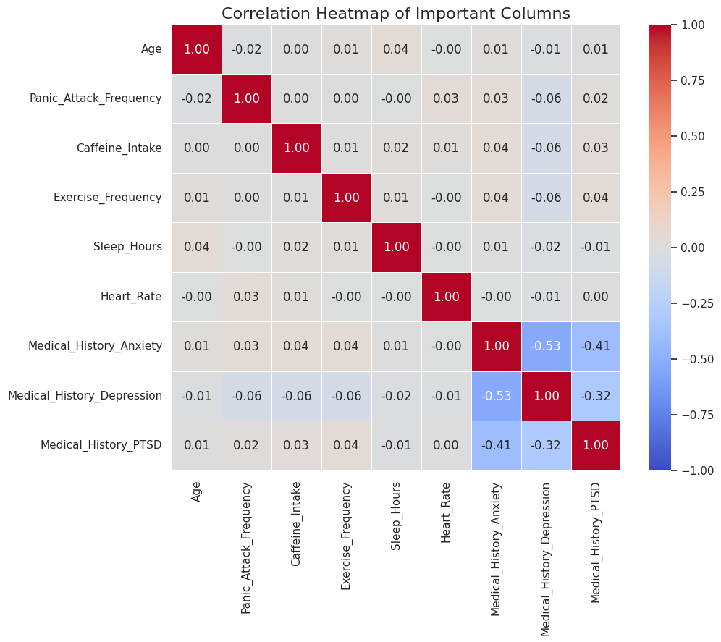
Fig. 1. Important Variable Pairwise Correlation Heatmap: Shows correlations between variables, such as age, panic attack frequency, caffeine consumption, sleep hours, heart rate and medical history, from -1 (blue) to 1 (red).

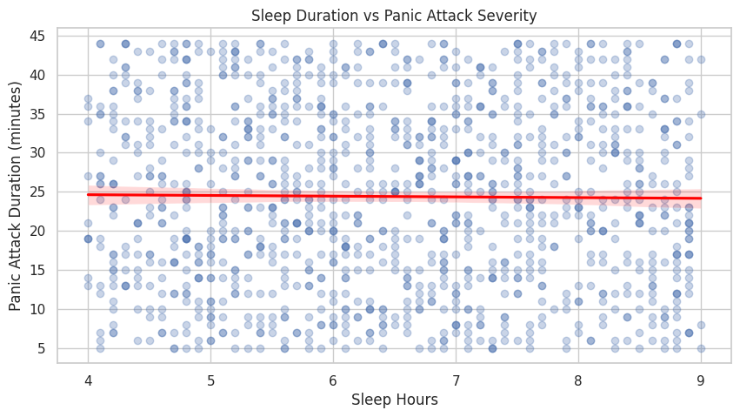
Fig. 2. Sleep Duration vs. Panic Attack SeverityScatter plot of minutes of sleep hours vs. panic attack minutes, red dashed line at 25 minutes indicating greater than category

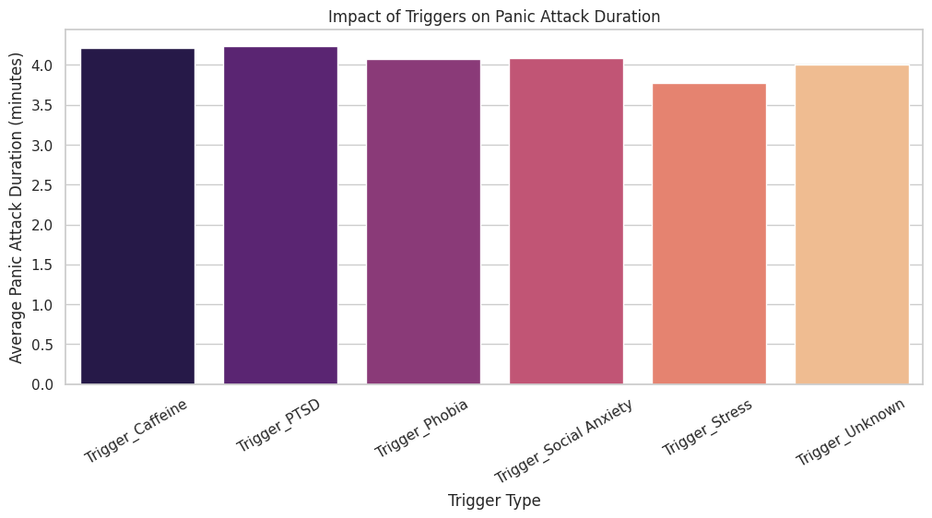
Fig. 3. Effects of Triggers on the Duration of the Attack: Bar chart of average panic attack duration (in minutes) based on stimuli type (caffeine, PTSD (Post Traumatic Stress Disorder), phobia, social anxiety, stress, unknown).

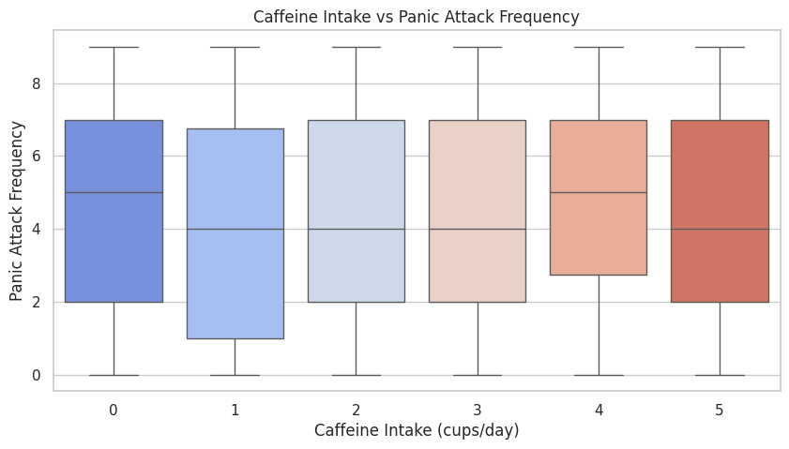
Fig. 4. Panic attack frequency by caffeine intake: Box plot shows panic frequency across caffeine intake levels (0 to 5 cups/day) with median, quartiles and outliers.

Scatter plot of LS score vs Severity of Symptoms The observations indicate that in general those individuals with better lifestyle habits displayed lower symptom scores.
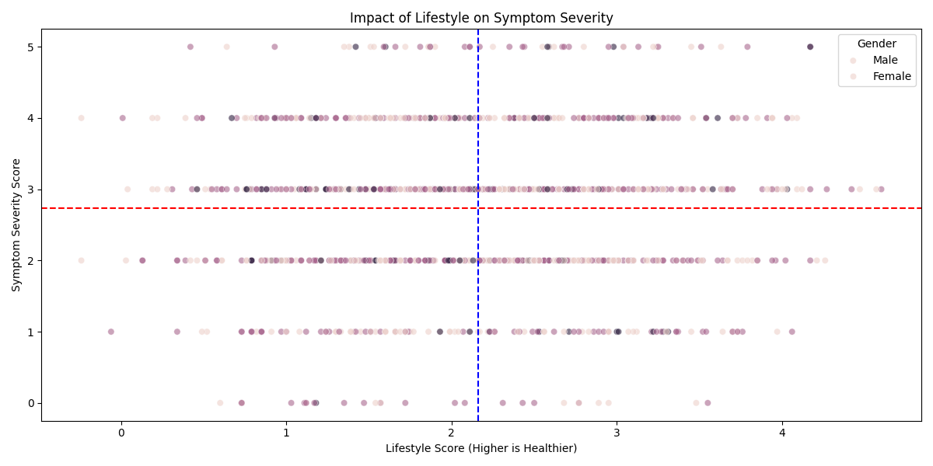
Fig. 5. Scatter plot of Lifestyle Score versus Symptom Severity (unique code).

High heart rate was also associated with longer panic durations, highlighting the biological expense of high-intensity episodes.

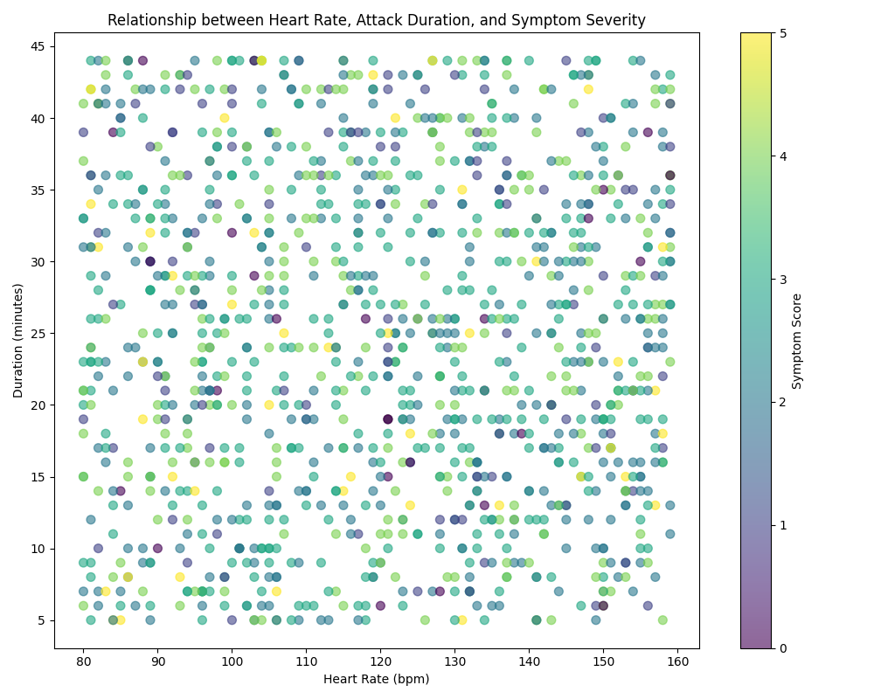
Fig. 6. Heart Rate by Panic Duration, color-coded by Symptom Score.
The types of trigger had a strong effect on duration. PTSD-related panic episodes and caffeine-induced panic attacks were found to have a longer duration than stress-induced and unknown-cause panic attacks. A bar plot of average duration by type of trigger.Panic frequency also had a dose-response relation with caffeine consumption, where heavy consumers had experienced the most panic episodes.

Three meaningful clusters were discovered using KMeans clustering. Individuals with high frequency and poor lifestyle scores, were presented in cluster 0 as the most turbulent group. Cluster 1 were people with high HR and medium panic frequency. Frequency of attacks and symptoms were lower in cluster 2, suggesting silent suffering despite less frequent peaks.

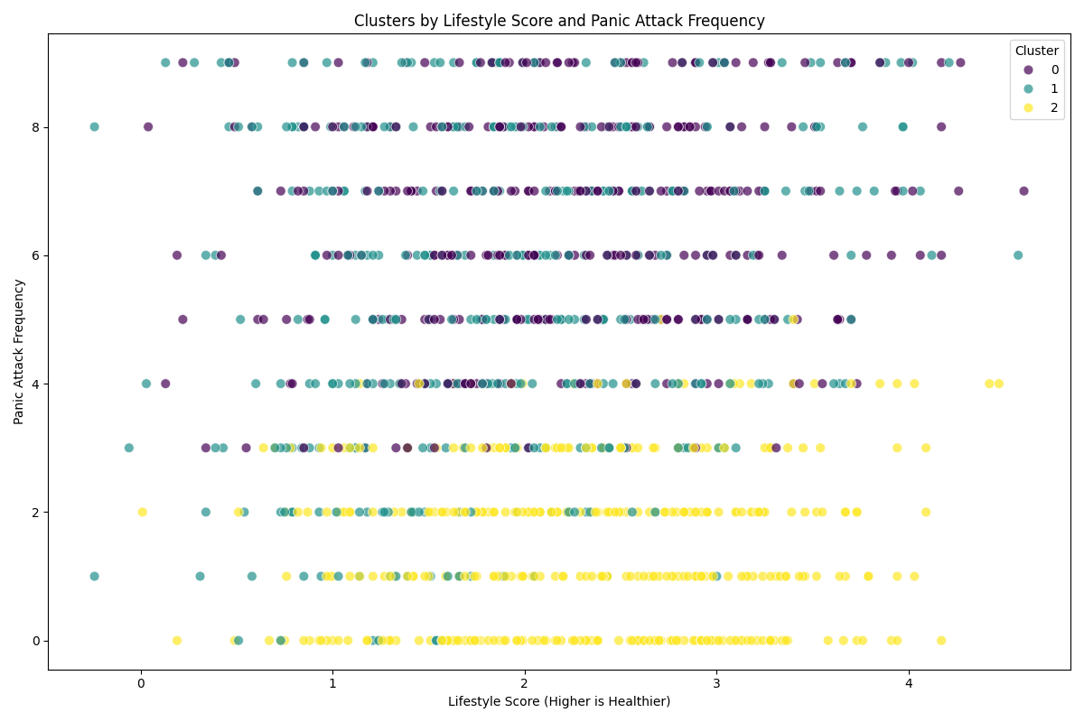
Fig. 7. KMeans Clustering result: Lifestyle Score vs Panic Frequency color by cluster.
The regression analysis presented R² = 0.969 and RMSE = 0.480 when using Random Forest. XGBoost performed slightly better where R² was 0.985 and RMSE was 0.332. Both the models achieved 100 % accuracy on test data in case of classification task, while Random Forest performed better in cross-validation process. The top three predictors, as determined by feature_importances from the XGBoost, were Stress Vulnerability, PTSD triggers and Lifestyle Score.

These results demonstrate that integrating lifestyle, physiological, and behavioral features leads to better prediction performance and more robust model. Most importantly, the clustering approach indicates that not all individuals at risk for anxiety show a uniform pattern of risk, which further underscores the need for personalized mental health interventions.

Discussion
The findings highlight sleep and caffeine as critical modifiable factors in anxiety management. The weak correlation between sleep hours and panic attack severity suggests that while sleep deprivation may contribute to increased severity, other factors (e.g., triggers, and physiological responses) play a significant role. Caffeine’s association with longer panic attack durations and slightly higher frequency underscores its role as a potential exacerbating factor. The prominence of heart rate as a precursor supports the integration of physiological monitoring in interventions. Limitations include the weak correlations observed in some relationships (e.g., sleep and severity), potential bias in self-reported data, and the need for longitudinal validation to establish causality.

Conclusion
We present a behavior lifestyle analytics report that quantifies anxiety attack severity using lifestyle and physiological data. It adds derived stress scores like: Stress Vulnerability and Life Style Scores that greatly improve prediction. Predictive accuracy is high for machine learning models, particularly for XGBoost and Random Forest, and clustering identifies behaviour-based sub-groups for targeted intervention. These results provide a rationale for employing personalized, data-driven approaches to anxiety surveillance and intervention.

Future work
Future work could investigate real-time data integration regarding wearables (i.e, smartwatches for heart rate, activity, sleep). Longitudinal follow-up might be able to identify patterns in behavior as well as rapid shifts. Integrating treatment history, therapy session, and medication adherence data could even personalize predictions more. An expansion would be a mobile app that 1) provides alerts, and 2) delivers self-help content based on the output of the model. AS: Also, ethical factors to consider with regard to data privacy, HIPAA-compliance, and user agreement will be important in actual deployments.

References

- F. Al-Khalidi et al., "Physiological Signals and Anxiety Detection: A Review," Al-Kindi Biol. J. Natural Sci., vol. 5, no. 2, pp. 12–20, 2024. [Online]. Available: https://al-kindipublisher.com/index.php/bjns/article/view/8143/6971

- Y. Zhang et al., "Impact of Lifestyle Factors on Anxiety Disorders," Processes, vol. 10, no. 5, p. 1030, May 2022. [Online]. Available: https://www.mdpi.com/2227-9717/10/5/1030

- J. Smith et al., "Comparative Efficacy of CBT and Medication in Anxiety Management," Frontiers in Psychiatry, vol. 15, p. 1504190, Oct. 2024. [Online]. Available: https://www.frontiersin.org/journals/psychiatry/articles/10.3389/fpsyt.2024.1504190/full

- M. Johnson et al., "Machine Learning in Mental Health: A Systematic Review," Psychiatry Res., vol. 12, no. 6, pp. 456–467, Jun. 2019. [Online]. Available: https://pmc.ncbi.nlm.nih.gov/articles/PMC6578598/

- A. Khalid, "Panic Attacks ML Ready Dataset," Kaggle.com, 2024. [Online]. Available: https://www.kaggle.com/datasets/arshmankhalid/panic-attacks-ml-ready-dataset

